Economy Mini PA Amplifier 60W/30W FA-60SM/FA-30SM

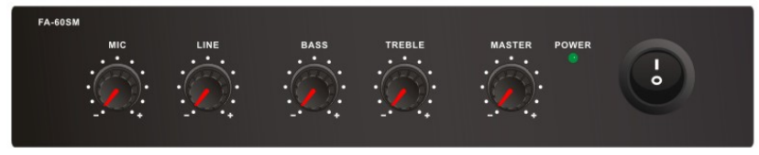
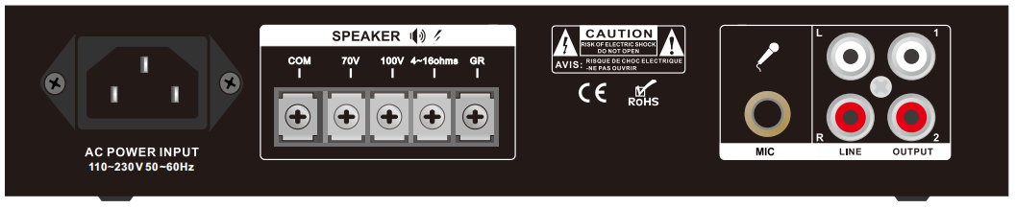

Features:
l Compact mini size public address amplifier
l Built-in 100V/70V transformer technology
l Tabletop amplifier with 1U Height
l Rate power output at 30W and 60W , Speaker output of 100V or 70V & 4Ohms-8 Ohms-16 Ohms
l Two AUX input and one RCA line output
l Volume control for AUX, bass/treble and master
l With short-circuit, clip, overload and high temp protection
l AC230V or 110V both operation system

Specification:

Model | FA-30SM |  | FA-60SM
Description | Public Address System Mixer Amplifier
Rated Power Output | 30W |  | 60w
Speaker Output | 70V, 100V and 4-16Ω
Input | Line1&line2 : | 10k ohms(Ω) 150-470 mV, unbalanced
Frequency Response | 60-15KHz
THD | <0.5% at 1kHz, 1/3 rated power
S/N Ratio | Line: 85 dB
Protection | High temp, short circuit, overload protection
Power Supply | AC110V-230V, 50-60Hz
Power Consumption | 37.5W |  | 75W
Dimension | 220(W)×20(D)×45(H)mm
Gross Weight | 3kg
Warranty | 2 years

